Start your application for In Concert – Secondary Choral Festival
Welcome to the Arts Unit Community portal. You can edit your school’s application at any time, receive program updates and ask questions via the Chatter feed.
Complete the following steps:
☐ apply to confirm your school’s interest
☐ principal approval for application
☐ create anticipated numbers and dates form
☐ create teacher professional learning form.
- Visit 2022 In Concert and select Apply for program on the right.
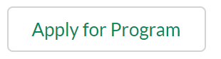
- Complete the application form. Note: If your principal or school name are incorrect, select ‘x’ and type in the name. Select ‘Next’ and ‘Finish’. Your application will be sent to your principal for approval. Your application status will change from ‘awaiting principal approval’ to ‘submitted’ once approved.
3. Select ‘In Concert – Anticipated Numbers’ and ‘create’ on the Participants tab. Complete the form and ‘Save’. It will be listed under Participants as PA-000 on your application page.
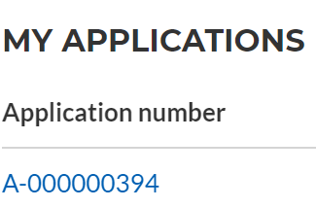
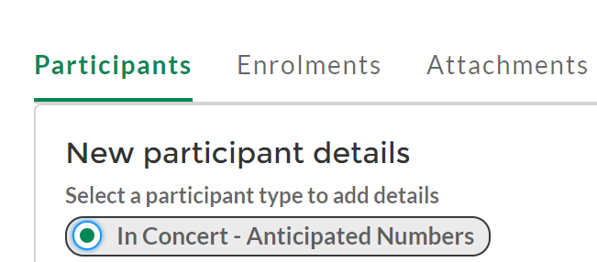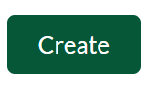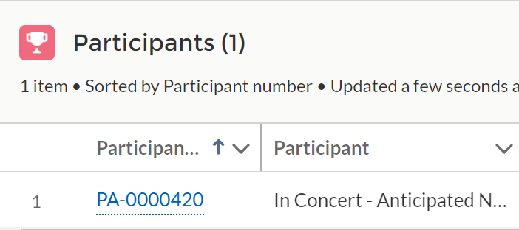
4. Select ‘teacher professional learning’ and ‘create’ under Participants to add your teacher professional form/s. Repeat for any additional teachers.
View or edit your application starting A-000 under ‘My applications’ on the home and program pages.
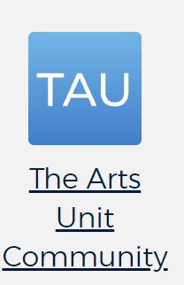
Tip: Add the Arts Unit Community portal tile in Inside the department to easily go back in to your application and view Chatter.
The music team will be in contact via email and the portal with program updates and advise when you need to add or upload more student information in 2022.

Please log an EdConnect remedy request or contact tausupport@det.nsw.edu.au for issues with TAU Community portal. InConcert enquiries – please email Elizabeth Scott.

