How to upload a video to YouTube
- Go to www.youtube.com

- Select ‘Sign In’ or ‘Create an Account’ if you don’t already have one.

- Once signed in, select the Camera Icon in the top right-hand corner.
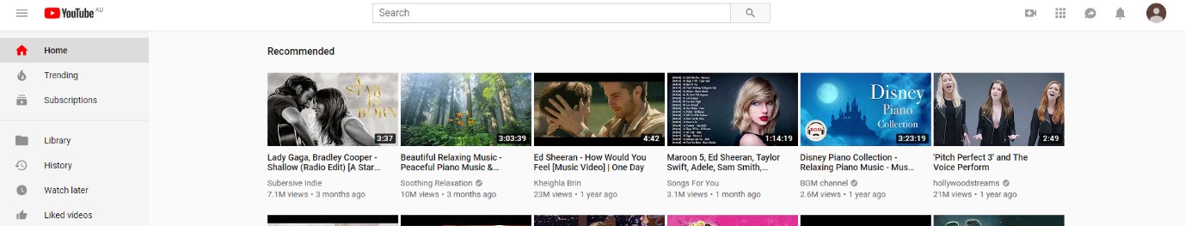

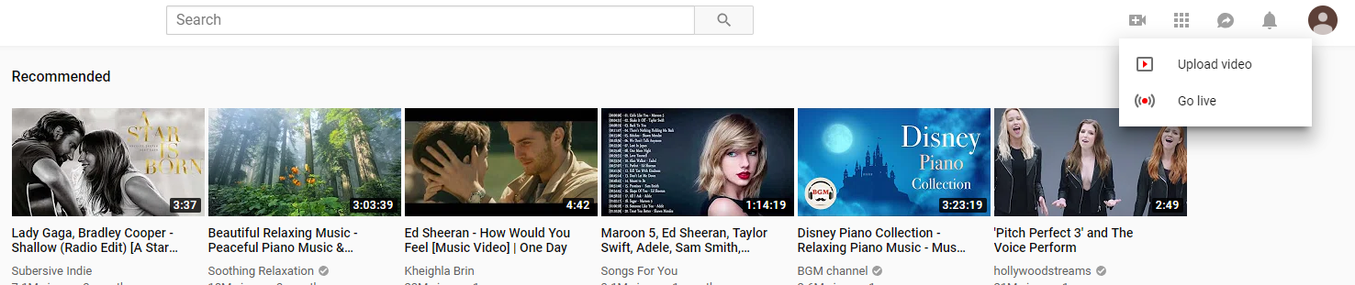
- Select ‘Upload video’.

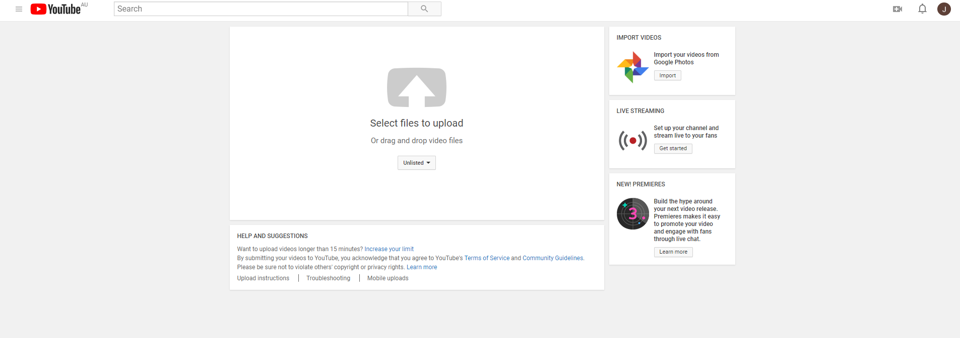
- Follow the instruction on screen to upload your video. Make sure you select ‘Unlisted’ to make your video private.
Make sure you select ‘Unlisted’

- When your video has successfully uploaded, you will be given a URL. Copy this URL into the online Aboriginal Dance Company application form.

- You will be contacted directly if there are any issues viewing your YouTube link.

For further information or if you have any questions, please contact the Arts Initiatives team via email artsinitiatives@det.nsw.edu.au
Ashley Napoleoni - Program Coordinator
Nicola Marshall - Support Officer

