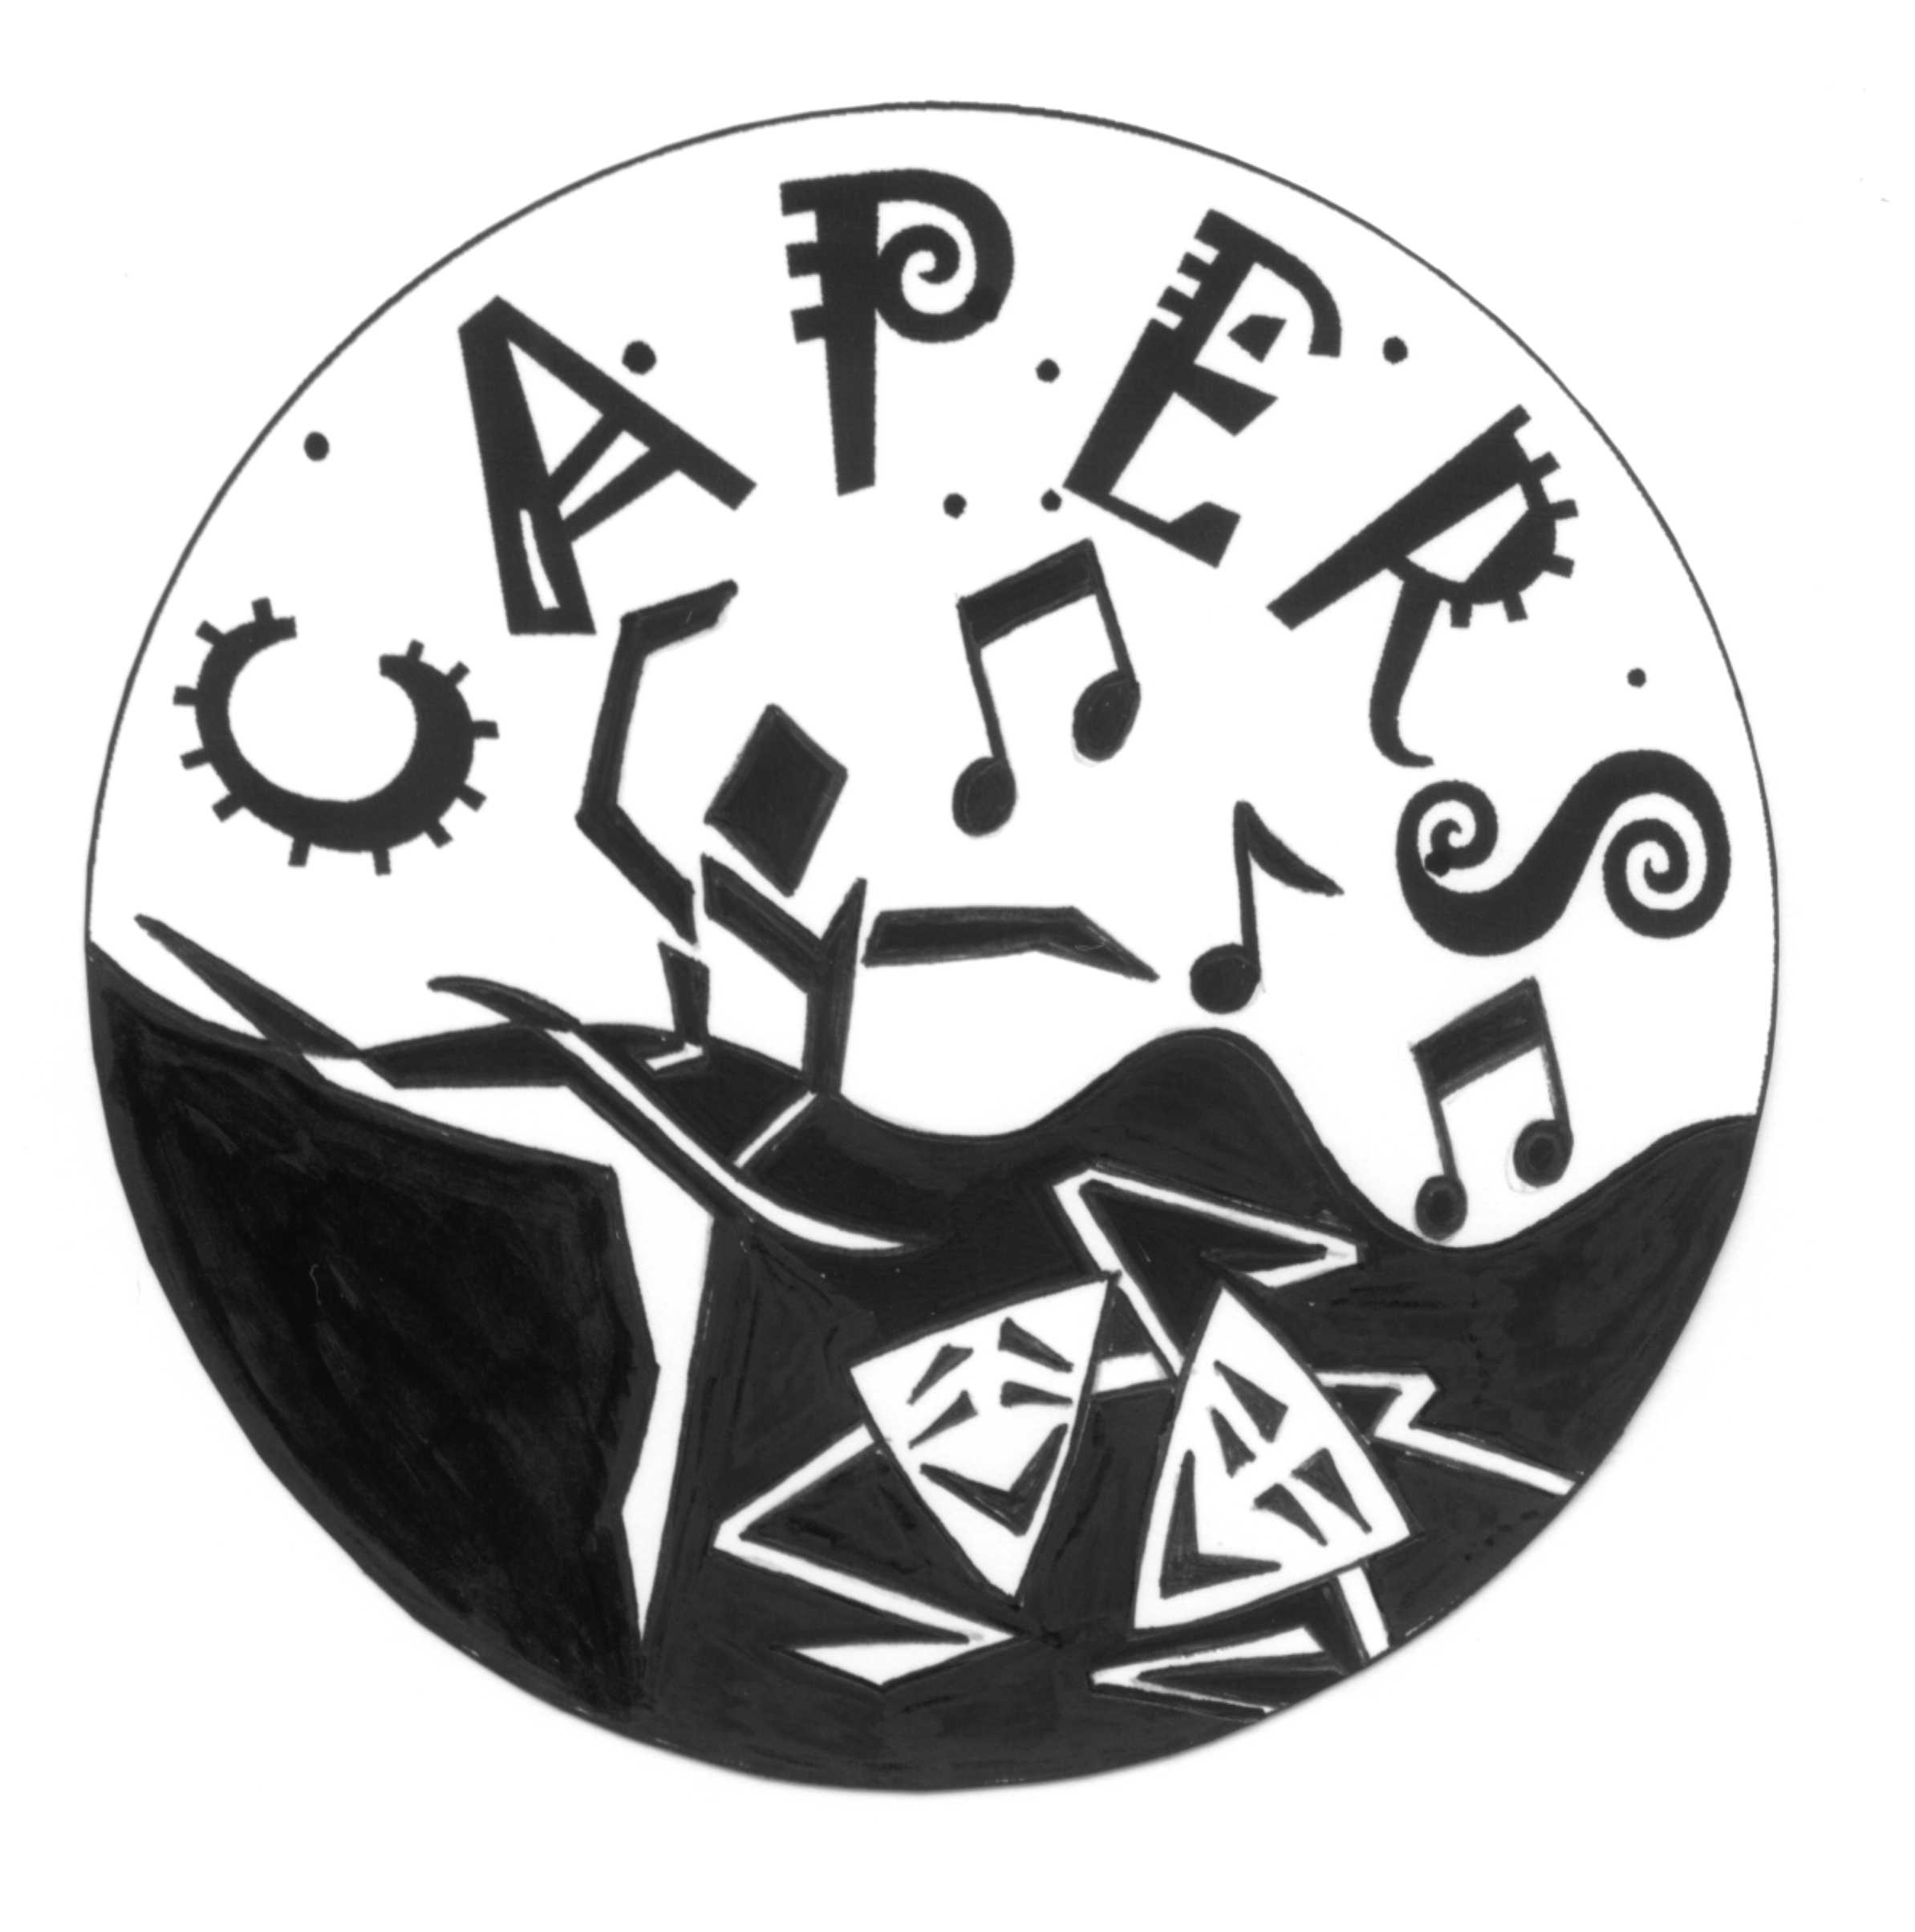

Featured dance auditions
CAPERS would like to welcome you to audition as a featured dancer in CAPERS 23.

Video Performance Requirements
Applicants submit only ONE two-minute video which consists of either:
- Option 1: A two-minute solo in Modern/ Contemporary or jazz style OR
- Option 2: A one-minute solo in Modern/ Contemporary or jazz style to be combined with a one-minute solo in a style of your choice.
The solos must be uploaded as one video.
- Applicants to identify themselves at the beginning of their video.
- Ensure audio quality of the video is clear.
- Applicants should be dressed in appropriate attire (please see below).
- Applicants' full body must be fully visible in the video at all times.

Process
Please email video link to breanna.mcfadyen1@det.nsw.edu.au
Remember to review the video before sending it in your email and ensure that it is appropriate for audition.
Closing date to receive the videos – Friday 16 June 2023
Videos will be viewed by the panel during the following week and students will be notified by end of Term 2.
For any further information, please contact breanna.mcfadyen1@det.nsw.edu.au or di.c.hall@det.nsw.edu.au or Mobile 0439 472 448

Appropriate Dance Attire
Girls: Tight fitting clothing eg Leotard/tights/unitard (no crop tops)
Boys: T-shirt/tights/bare feet
- Appropriate dance shoes or bare feet
- Applicants should wear plain, form fitting dance wear
- No jewellery
- Hair tied back and off the face

Criteria
Applicants will be assessed on:
- Demonstrated dance skills such as Flexibility, Coordination and Endurance
- Technical skill and performance quality eg expression, projection or anything that engages your audience.
- Strength and control of a range of locomotor and non-locomotor movement incorporating turns, falls, balances and jumps

Tips for audition video
- Recording from a phone or tablet mounted on a tripod is sufficient quality for the audition video.
- Record the performance in one continuous take from a wide angle to ensure all performers are seen. Do not zoom in and out.
- Spend time rehearsing, recording and reviewing your audition video
- Where possible, minimise external light sources by covering windows to avoid interference with visual contrast.

Tips for uploading to YouTube
- Visit youtube.com and create an account or sign in.
- Select upload.
- Follow the instructions onscreen to upload your video.
- Once uploaded, on privacy settings select unlisted (anyone with this link can view) and save changes. This is important because it means the general public cannot view the link.
- When complete, your video will have a URL.
- Send email to breanna.mcfadyen1@det.nsw.edu.au with your URL link.

