NSW Public Schools 2024 Aboriginal Dance Company

Information Package

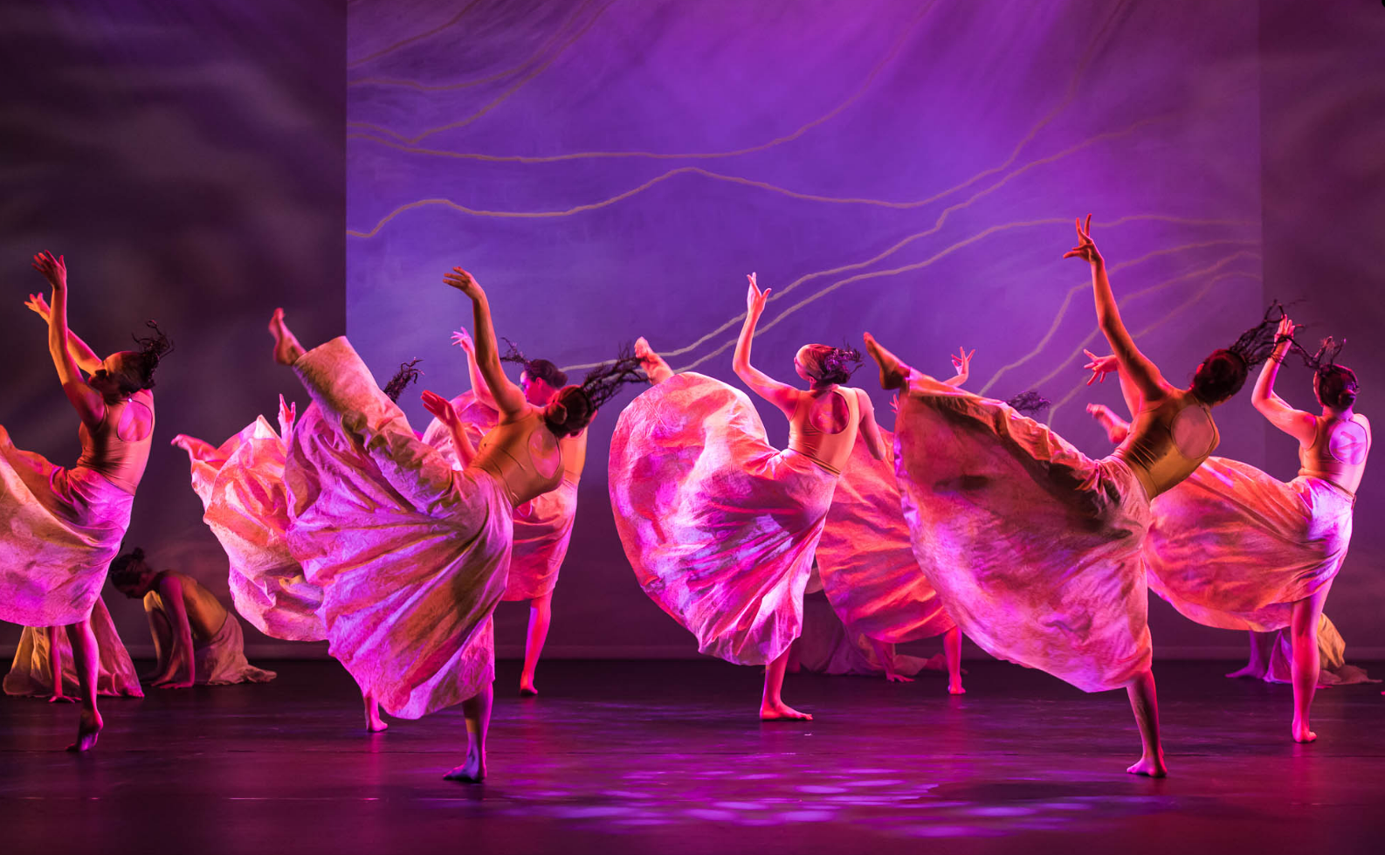

For further information or enquiries please contact the Arts Initiatives team
via email artsinitiatives@det.nsw.edu.au
The Arts Unit, Corner of Toothill Street & The Boulevard, Lewisham NSW 2049.
Locked Bag 1500, Petersham NSW 2049.
Program Coordinator – Ashley Napoleoni, Arts Initiatives and Events Officer
Ph (02) 8512 1190

2024 NSW Public Schools Aboriginal Dance Company
- About the program
- Key information
- Rehearsal and performance schedule
- Condition of membership
- COVID-19 information and processes
- Accommodation possibilities
- Behaviour Code for students

About the program
The NSW Public Schools Aboriginal Dance Company is an audition-based dance ensemble for Aboriginal or Torres Strait Islander students in years 7-12 who attend a NSW public school, and excel in contemporary Indigenous dance. The Company is a partnership between the NSW Department of Education Arts Unit and Bangarra Dance Theatre.

The Company is a featured ensemble at the State Dance Festival, in the Schools Spectacular and at a number of other high profile events, including the Nanga Mai awards. Students selected for the Company will experience new and exciting opportunities to perform in 2024.

The NSW Public Schools Aboriginal Dance Company has been coordinated by the Arts Unit since 2011. Since that time, it has grown into a highly sought after cultural performance experience for Aboriginal and Torres Strait Islander students in Years 7-12.

In recent years, members of the Company have also participated in a professionally recorded Acknowledgement of Country which was made available on application to all areas of the Department to include as part of their broadcasts, festivals, meetings, and professional learning forums.

Past members of the Aboriginal Dance Company have gone on to study at NAISDA and perform with the Internationally renowned Bangarra Dance Theatre.

Key information

Program fees
To ensure that the NSW Public Schools Aboriginal Dance Company can operate under changing educational and economic structures, we are required to charge a membership fee. The 2024 membership fee is $300 (incl GST). This subsidised fee covers expert tuition, administration, venue costs and costume requirements for both the State Dance Festival and the Schools Spectacular.

Travel and accommodation information
Participating students, their families and schools are responsible for their own travel arrangements to all rehearsals and performances.

How to apply for the NSW Public Schools Aboriginal Dance Company
Students will need to learn the set repertoire, film themselves performing it and complete the steps below to apply for a place in the company.

The set repertoire will be made available when applications open on Thursday 1 February.

To apply, students must complete the online application form and upload the following 3 components:

- Students will need to record themselves performing the set repertoire. This should be shot in landscape with the student applying performing and visible from head to toe. Groups are not encouraged as students are hard to identify. Multiple applications from schools are accepted.
- A filmed 1 minute Viva Voce (short speech) introducing themselves, their school, their mob, their dance experience, why they would like to be part of the Aboriginal Dance Company and what they hope to do in the future.
- A headshot photograph.

Marking criteria
Students will be assessed by a panel of four consisting of three members of the Bangarra Dance Theatre’s Youth Programs team and a member from the department of education. Students will be given a grading against the following components:
- Dance technique
- Performance quality
- Cultural connection
- Creative expression
The students engagement at school will also be assessed using the teachers reference.
2024 rehearsal and performance schedule
Event | Date | Venue | Time
State Dance Festival |  |  | Term 3
State Dance Festival Rehearsal | Term 3, Week 7  Monday 2 September -  Friday 6 September | Bangarra Dance Theatre, Hickson Rd, Walsh Bay | 9:00 am – 3:00 pm
State Dance Festival Rehearsal | Term 3, Week 9  Monday 16 September -  Thursday 20 September | Sydney Dance Company,  Hickson Rd, Walsh Bay | 9:00 am – 3:00 pm
State Dance Festival | Term 3, Week 9  Friday 20 September | Seymour Centre, Chippendale | 9:00 am – 10:00 pm (TBC)
Schools Spectacular |  |  | Term 4
Schools Spectacular Rehearsal | Term 4, Week 4  Monday 4 November -  Friday 8 November | Bangarra Dance Theatre, Hickson Rd, Walsh Bay | 9:00 am – 3:00 pm
Schools Spectacular Rehearsal | Term 4, Week 7  Monday 25 November -  Wednesday 27 November | Fairfield RSL, Fairfield | 9:00 am – 3:00 pm
Schools Spectacular Dress Rehearsal | Term 4, Week 7  Thursday 28 November | Qudos Bank Arena | 9:00 am – 7:00 pm (TBC)
Schools Spectacular | Term 4, Week 7  Friday 29 November  Saturday 30 November | Qudos Bank Arena | 9:00 am – 10:00 pm TBC
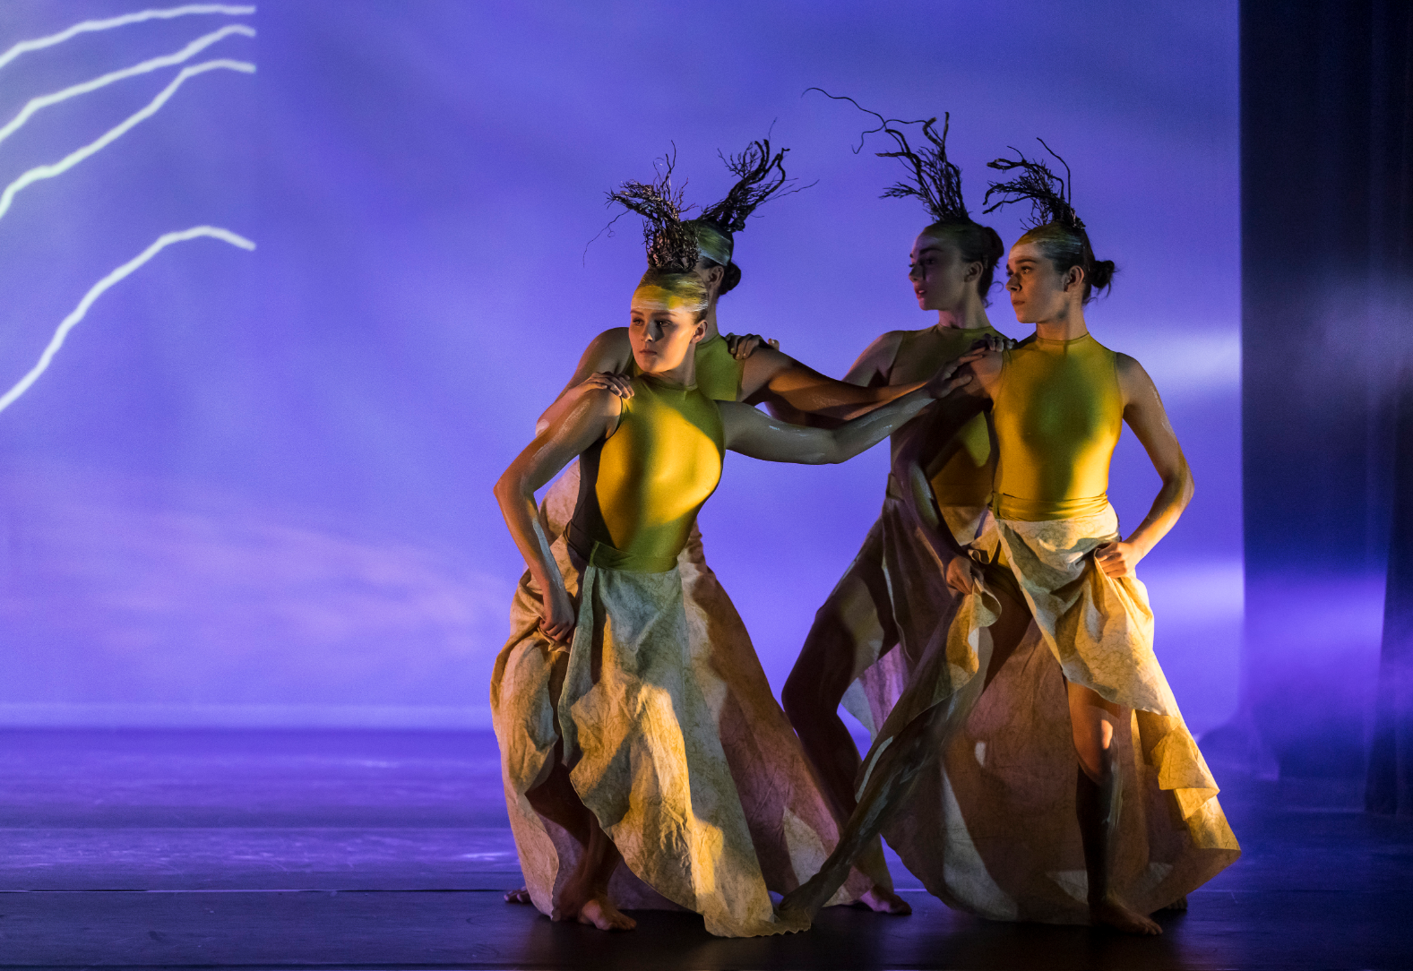
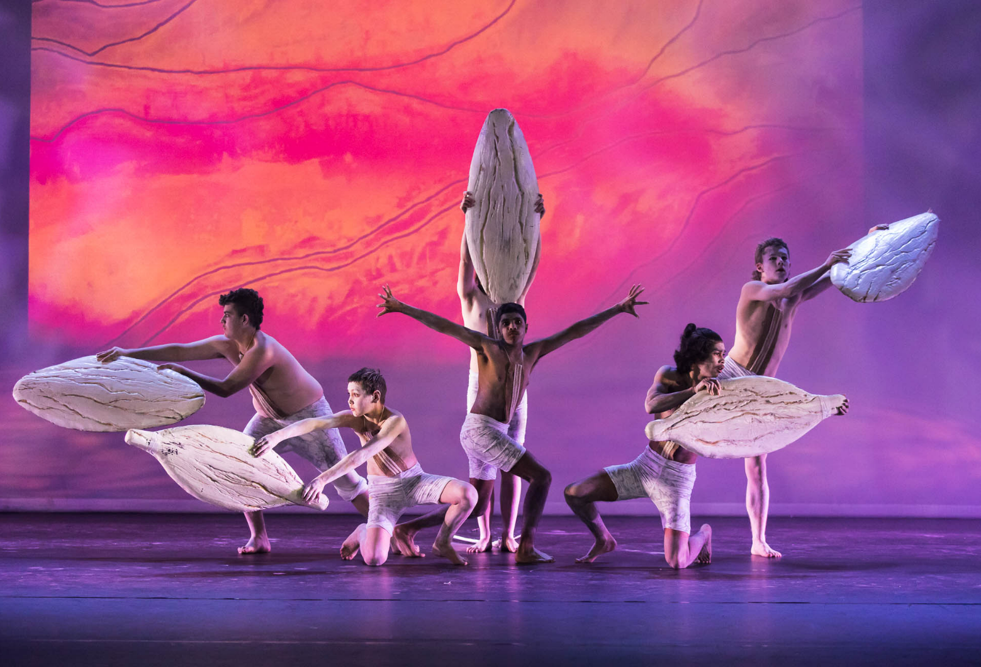

Conditions of membership 2024
The NSW Public Schools Aboriginal Dance Company members will be expected to:
- Attend all rehearsals, workshops, and performances in the schedule.
- Demonstrate a positive and dedicated attitude and behave in an exemplary manner at all rehearsals, workshops, performances, and events.
- Be responsible for the care of all resources issued and agree to pay for the repair or replacement cost of any resource damaged or lost whilst on issue.
- Assist staff in setting up and cleaning equipment as required at rehearsals and performances.
- Follow a regular home practise schedule.
- Plan study and school commitments to allow for attendance at all rehearsals and performances whilst maintaining their school work.
- Take responsibility for the negotiation of commitments with tutors and coordinators well in advance of a clash occurring.
- Inform the company coordinators of any absence prior to the rehearsal by phoning Ashley Napoleoni program coordinator on 8512 1190.
- Abide by The Arts Unit Code of Conduct (please see below).
- The Aboriginal Dance Company is an extension of school programs. Students are encouraged to be supportive of their school ensembles.

Please Note: If a Company member does not abide by the conditions and codes as outlined above, they may be withdrawn from the program. As a member of the Company, students are representing themselves, their school, and The Arts Unit. Exemplary behaviour is expected at all times.

COVID-19 information and processes
As your child is participating in an extracurricular off-site activity, it is essential that parents and carers acknowledge and understand the risk of COVID-19 and the risk management processes in place by the program organiser:
I acknowledge that this event/activity is required to be held in accordance with any current NSW Health COVID-19 Public Health Orders and the NSW Department of Education’s policies and procedures. I acknowledge and accept that there is a risk that my child may be exposed to COVID-19 whilst attending and participating at this event. I confirm that my child will not attend if displaying any symptoms of illness, and/or if directed to isolate under public health orders.
If your child presents as unwell (including with mild COVID-19 symptoms) they will be temporarily isolated and the parent/carer will be contacted to collect their child immediately from the venue. Throughout the entirety of this program, staff and students will be strongly encouraged to wear masks where possible and practice social distancing.
Please see the NSW Department of Education COVID-safe advice and COVID-smart measures for further information.

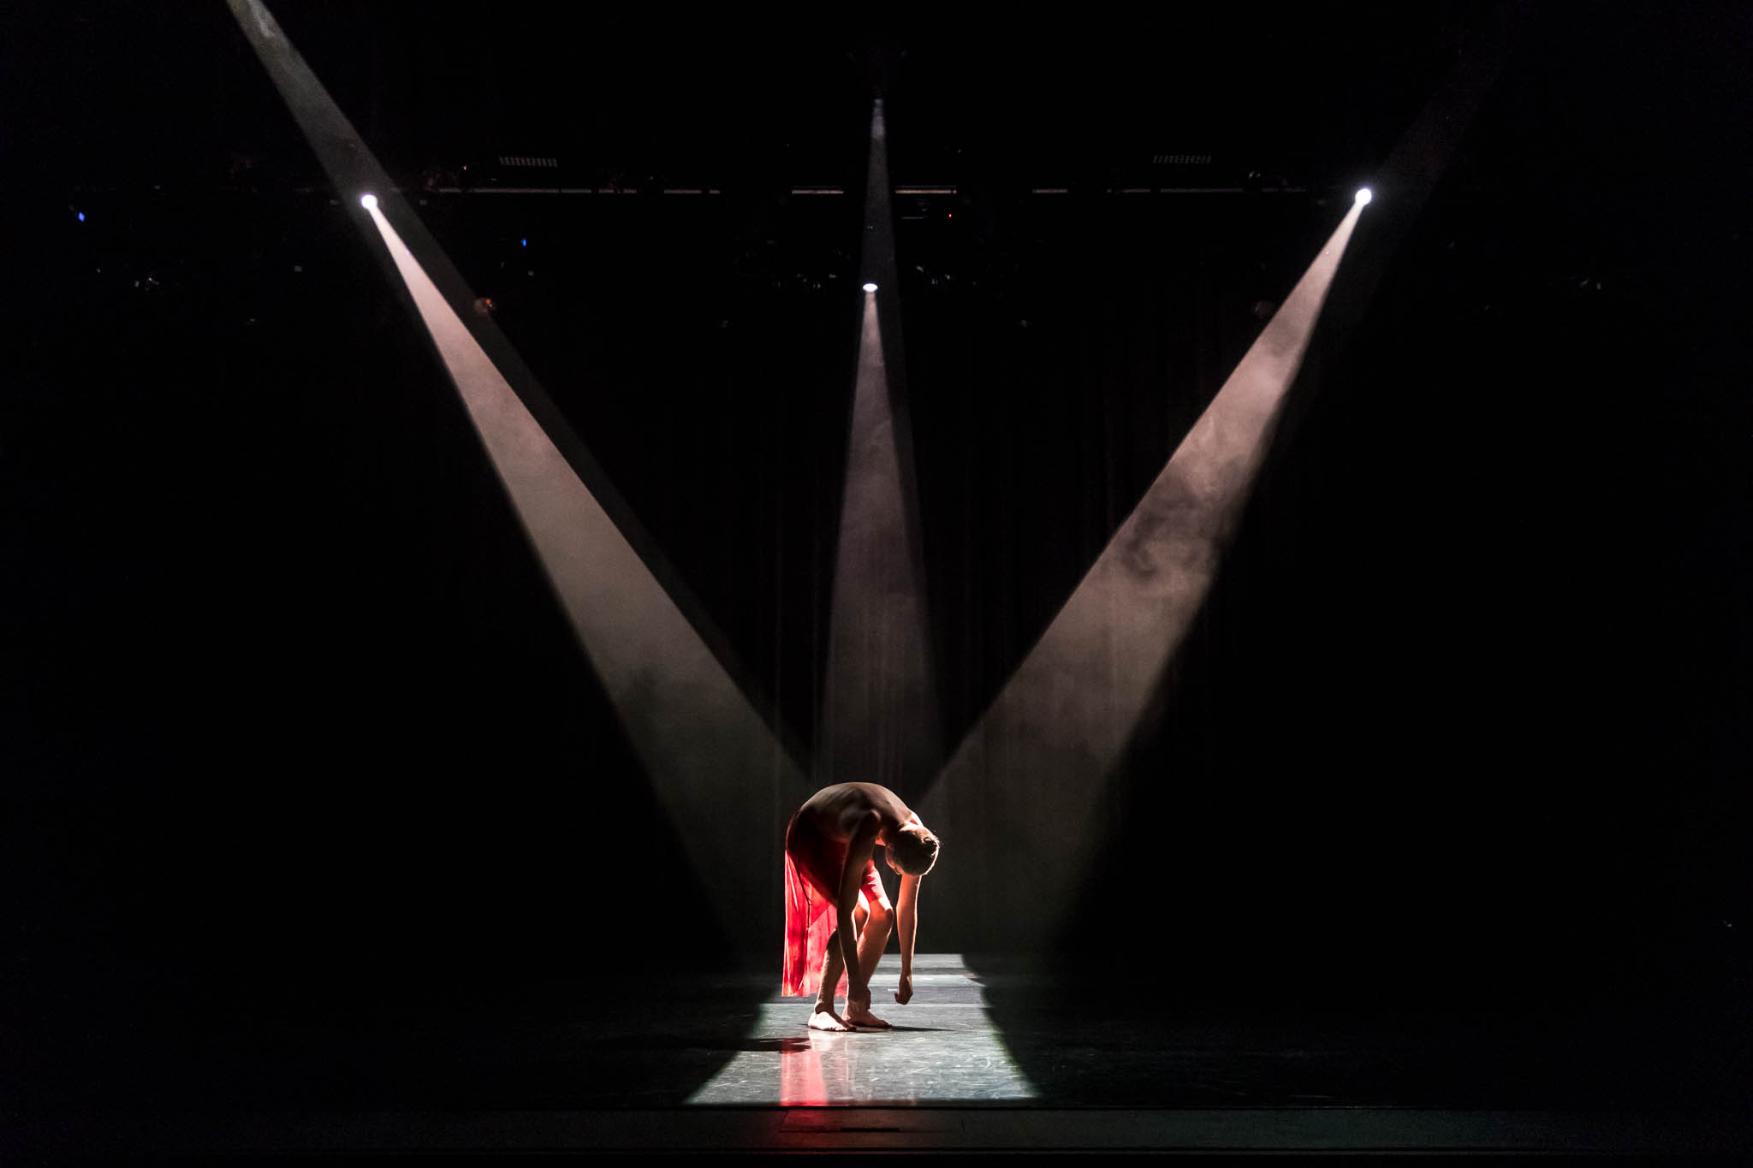

Behaviour code for students
The Arts Unit is a specialist unit within the New South Wales Department of Education that provides a unique range of opportunities across all of the performing and visual arts, including dance, drama, music, visual arts, public speaking and debating to the students and teachers in NSW Government Schools.

Statement
The Core Rules of Discipline for students participating in arts-based programs, events or activities conducted by The Arts Unit provides a clear statement of the NSW Department of Education expectations of students.

Relevance
The Core Rules of Discipline apply to students enrolled in NSW Government Schools, who are selected or nominate to participate in arts-based programs, events or activities in respect to their conduct whilst participating in such programs, events or activities conducted by or for the Department.
The Core Rules of Discipline have been developed as a means of ensuring the safety of ALL students who participate in arts-based programs. Students must comply with the Core Rules of Discipline at all times whilst participating in the arts-based activity. Participation in arts-based activities is not mandatory for students in government schools, and a student who is unwilling to agree to comply with the Core Rules of Discipline will not be approved to participate in the arts-based activity.

Definition
‘Student’ means any students enrolled in a NSW Government School participating in programs, events or activities coordinated by The Arts Unit.
‘The Department’ means the NSW Department of Education.

Behaviour Code for Students in NSW Public Schools
Students participating in programs, events or activities conducted by The Arts Unit will adhere to the Core Rules of Discipline in NSW Government Schools. Prior to participation in a program, event or activity all students over 18 must sign an agreement acknowledging the Core Rules of Discipline and the student’s willingness to comply with them. Students under 18 must have a parent or carer sign an agreement on the student’s behalf.
- Comply with instructions given by teachers at all times. Attend every day required, unless they are legally excused, and be at the program, event or activity on time and be prepared to actively participate and learn.
- Maintain a neat appearance, including adhering to the requirements of the program, event or activities uniform, dress or costume requirements.
- Behave safely, considerately and responsibly, including when travelling to and from the program, event or activity.
- Show respect at all times for program, event or activity coordinators, teachers, other school staff, tutors, and helpers, including following rules specific to the program, event or activity, speaking courteously and cooperating with instructions and learning activities.
- Treat other students and adults involved in the activity with dignity and respect.
- Care for property belonging to themselves, the venue and others.
- Respect property belonging to themselves, the venue or others.
Note: The department has a duty of care to all students and provides a safe and secure learning environment for all of its students, including where the student is involved in an approved activity away from his or her school. Behaviour by a student that affects the safety of others, such as harassment, bullying, violence and illegal or anti-social behaviour of any kind will not be tolerated. This includes but is not limited to smoking, consumption of alcohol and possession or use of illegal drugs.

Consequences for student breaches of these core rules of discipline at a program, event or activity conducted by The Arts Unit:
The Manager of The Arts Unit, in consultation with the relevant school Principal, may deal with any breaches of this code by imposing appropriate consequences which may include exclusion from the program, event or activity. Serious breaches of the code may also be subject to discipline in accordance with policies outlined in the document Students Discipline in Government Schools:
education.nsw.gov.au/policy-library/policies/student-discipline-in-government-schools-policy
As a result of a breach of the Core rules of Discipline, a student may face disciplinary action at his or her school. In cases of serious misbehaviour by a student, including but not limited to violence or possession of illegal drugs, this may result in suspension or expulsion.

