NSW Public Schools Secondary Aboriginal Dance Workshop 2024

Online Workshop Information Package
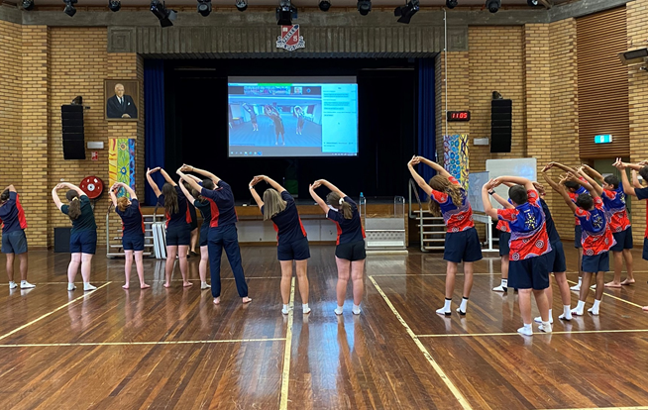

For further information or enquiries please contact the Arts Initiatives team
via email artsinitiatives@det.nsw.edu.au
The Arts Unit, Corner of Toothill Street & The Boulevard, Lewisham NSW 2049.
Locked Bag 1500, Petersham NSW 2049.
Program Coordinator – Ashley Napoleoni, Arts Initiatives and Events Officer
Ph (02) 8512 1190

Secondary Aboriginal Dance Program 2023
- About the program
- Key information
- Acceptance information
- Program dates
- Accessing the sessions
- Workshop schedule
- Professional learning – teaching standards
- Workshops and Zoom etiquette
- Organising teacher checklist
- Payment Advice form

About the program

The online Secondary Aboriginal Dance Workshops are run by the NSW Department of Education Arts Unit in collaboration with the internationally renowned Bangarra Dance Theatre. This program has been designed to engage and educate students in contemporary Indigenous dance.

The online Secondary Aboriginal Dance Workshops are for NSW Public School groups of Indigenous and non-Indigenous students and their teachers. The online workshops are open to all NSW Public Schools.

Over a 1 hour and 15 minute online workshop, tutors from Bangarra Dance Youth Theatre will provide students and teachers with a contemporary repertoire.
Workshops must be actively supervised by a teacher from the school, and it is expected that student behaviour is appropriate to that of any school activity.
Please note there are limited places for the online workshops and your application does not guarantee your schools entry into the program.

Key information
Program dates: Friday 23 February and Friday 5 April
Mode: This program will be conducted live online (via Microsoft Teams).
Attendees: All schools must have at least 1 teacher in attendance for the teacher information briefing and for each workshop. Inviting community members to the workshops is strongly recommended.
Program inclusions:
- 1 hour and 15 minutes of student workshops.
Fees: Schools will be charged a flat rate of $100 per school (no GST). This is made up of:
Fee | Program element | Inclusions
$100.00 | Student workshops | Up to 20 students per school
 | Total: | $100.00 (no GST)

Acceptance information
Schools will be notified of their acceptance by reply email prior to the commencement of the program.
Applications close:
- Friday 9 February for Friday 23 February workshops
- Friday 22 March for Friday 5 April workshops.

Program dates for 2024
Student workshops
There are three time slots:
Session 1: 9:30am – 10:45am
Session 2: 11:30am – 12:45pm
Session 3: 1:30pm – 2:45pm.
When applying, schools will be given the opportunity to nominate their preferred time slot however, this does not guarantee your position. Schools must be available to attend either timeslot if necessary. All efforts will be made to accommodate the schools first preference.

Accessing the sessions
This year, the Secondary Aboriginal Dance Workshops will also be held online, helping to increase the flexibility of program delivery and facilitate accessibility for schools in rural and remote areas.
The sessions will be held using the virtual Microsoft Teams platform. Organising teachers will be sent information via email with a Microsoft Teams hyperlink for the teacher information session and the student sessions. Please join us online at least 10 minutes prior to the start time to allow for any technical difficulties to be addressed. Workshops will commence at the indicated time.
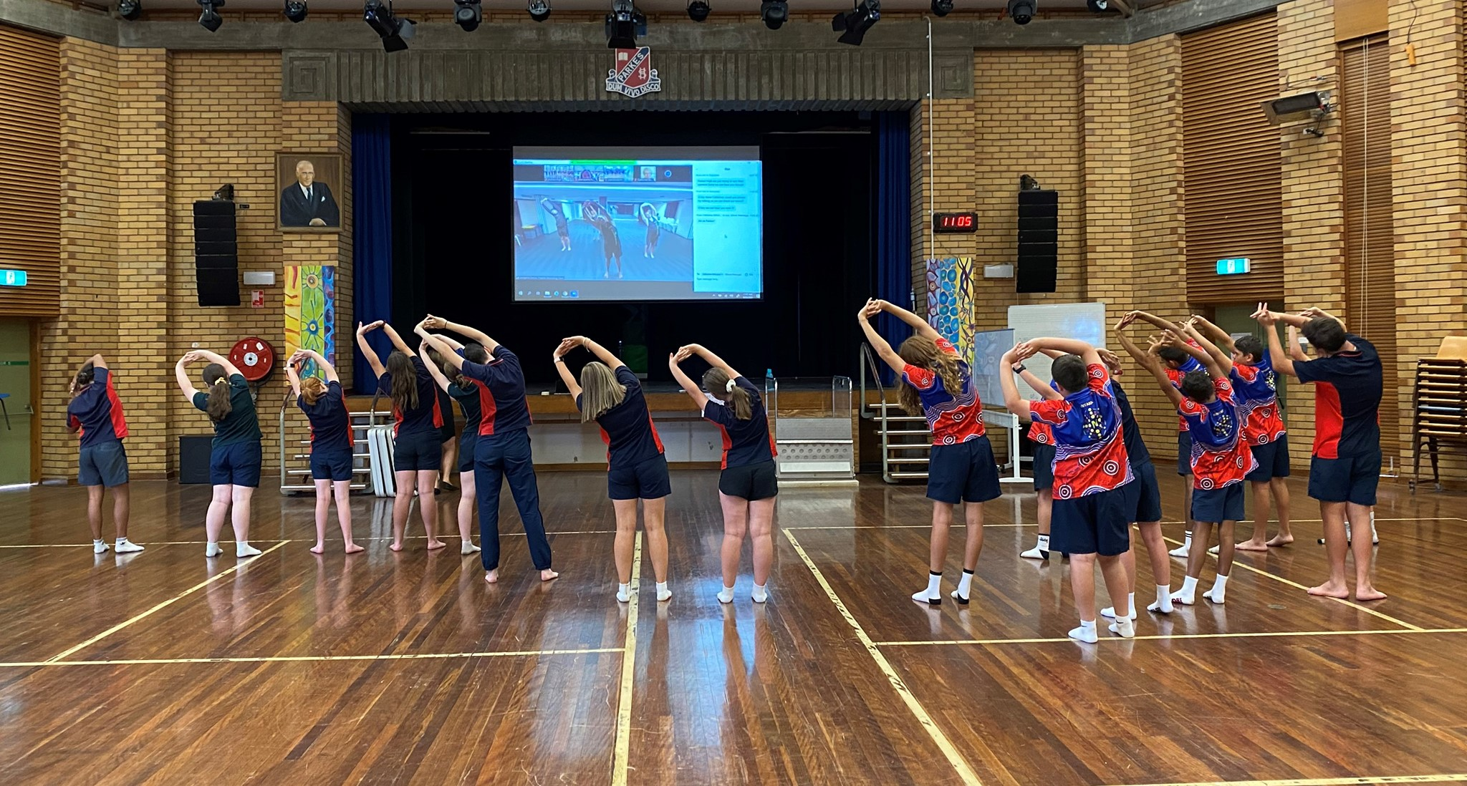
For the student sessions, you will need to have an area in your school available where students are directly facing the camera / screen and can clearly see and hear the tutors on Microsoft Teams while they are dancing. A classroom, hall or studio space with video capabilities (e.g. video conferencing or ‘connected classrooms’) works best.

Example of using Zoom and video conferencing technology in the school hall
(credit: Parkes High School)

Workshop schedule
Time | Activity
30min | Warm up
30min | Choreography
10min | Cool down and Wrap up
5min | Q&A

Professional Teaching Standards
This program addresses the following Professional teaching Standards for Teacher Identified Professional Development
1.4.2 Design and implement effective teaching strategies that are responsive to the local community and cultural setting, linguistic background and histories of Aboriginal and Torres Strait Islander students.
2.4.2 Provide opportunities for students to develop understanding of and respect for Aboriginal and Torres Strait Islander histories, cultures and languages.
6.2.2 Participate in learning to update knowledge and practice targeted to professional needs and school and/or system priorities.
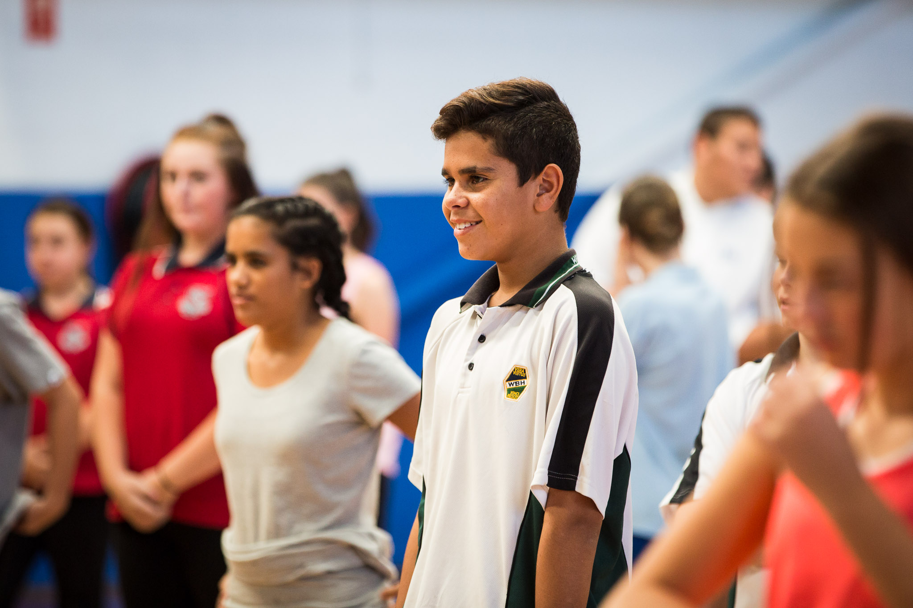

Workshop and Microsoft Teams etiquette
The following guidelines will help everyone get the most out of their online Secondary Aboriginal Dance Workshops.
- Please participate in the workshop with your audio on mute and your video on.
- Name on screen should be your school name.
- If students have questions they need to be directed to the teacher who can then ask any questions using either the chat function or the raised hand.
- There will be a TAU staff member monitoring the chat function throughout the workshop to address any concerns or questions you have.
- It is expected that all schools will attend the full program of workshops and have something to present at the final showcase.
- Where possible, it is hoped that schools will be able to have 2 staff members supervising the workshop and ensuring that students are respectful and cooperative.
- It is expected that all students attending the workshop will actively participate in the workshop activities. Teachers are asked to actively supervise the workshop and ensure that student behaviour is respectful and focussed on the learning.
- At the end of each workshop there will be a creative task set for schools to devise their own choreography to add on to the repertoire being taught. Teachers need to ensure that there is time between workshops for students to work as an ensemble to devise and learn work so that it is ready to be shown the following workshop.
- If you would like to use the choreography and music for school based performances please contact Ashley Napoleoni to seek permission from Bangarra.
- Please notify Ashley Napoleoni in advance of your workshop if there are any issues that might need to be addressed or email artsinitiatives@det.nsw.edu.au

Organising teacher – acceptance checklist
- Finalise your registration by completing and returning the Payment Advice form (final page of document). Upload the complete Payment Advice form into your online application or email directly to Arts Initiatives team: artsinitiatives@det.nsw.edu.au
- Ensure you have received a Microsoft Teams invitation link and email for the student workshop sessions. This will be sent out after applications have closed.
- For the student sessions, organise and/or book a space in your school that is suitable for dancing for the size of your group. Students will need to be able to clearly see and hear the tutors on screen (e.g. via a connected classroom or smartboard) and vice versa. A first aid kit on hand is also required.

- Students should be dressed in comfortable clothing that allows free movement and bare feet are preferable. All attending students will be expected to actively participate in the workshops.

- Students should have a water bottle available.

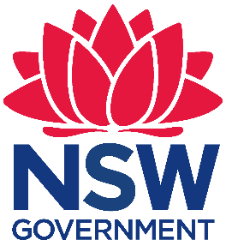
Payment Advice form

Secondary Aboriginal Dance Workshop 2024
The Arts Unit, NSW Department of Education

Name of school: __________________________________________
School Code: __________________________________

Schools will be charged a flat rate of $100 per school (no GST required) for the 2023 Secondary Aboriginal Dance Workshop. This is made up of:
Fee | Program element | Inclusions
$100.00 | Student workshops | Up to 20 students per school
 | Total: | $100.00 (no GST)

…………………………………………………………………………………………………….……………………………………………………………..
Once complete, please retain copies at school, you do not need to email them to the Arts Unit.
I understand that the school will be charged a fee of $100.00 for participating in the 2024 NSW Public Schools Secondary Aboriginal Dance Workshop. Fees are processed as a direct debit via an Intercompany Journal (previously Sundry Tax) after the first session.

Organising teacher
Name: __________________________
Signature: _______________________
Date: ___________________________
Principal
Name: ___________________________
Signature: _______________________
Date: ____________________________

