2024 NSW Public Schools All Ability Arts Program

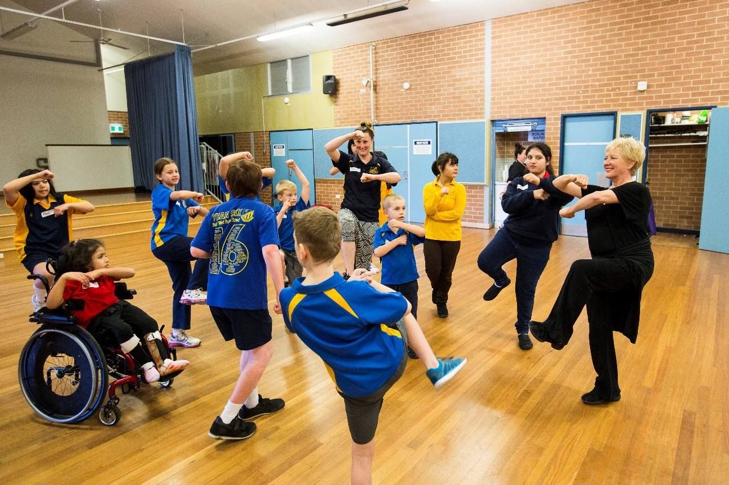
Dance workshops for students with disability

For further information or enquiries please contact the Arts Initiatives team
via email artsinitiatives@det.nsw.edu.au
The Arts Unit, Corner of Toothill Street & The Boulevard, Lewisham NSW 2049.
Locked Bag 1500, Petersham NSW 2049.
Program Coordinator – Ashley Napoleoni, Arts Initiatives and Events Officer
Ph (02) 8512 1190

Dance workshops for students with disability 2024
- About the program
- Organising teacher checklist
- Key information
- Workshop schedule
- What to bring and wear
- Supervising teachers
- Tutor information
- Payment Advice form

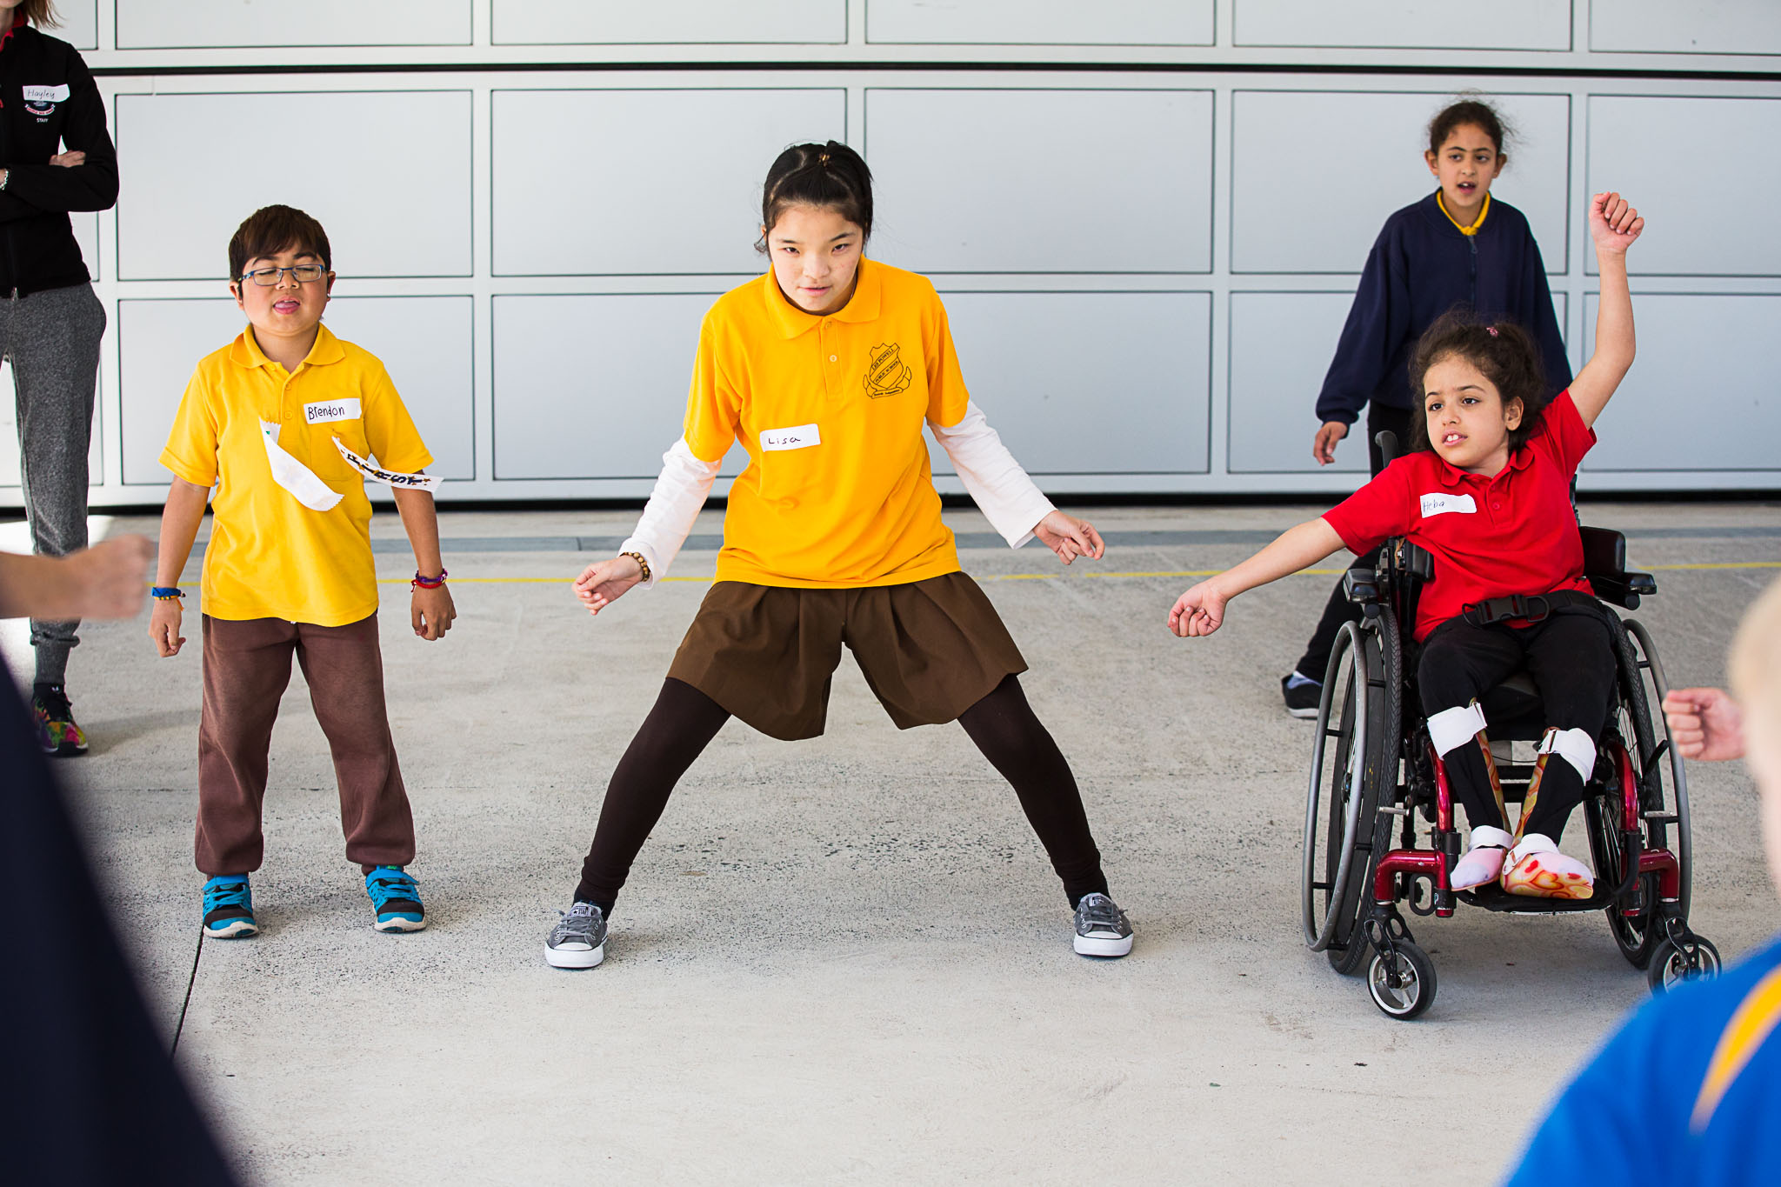

About the program
The dance workshops for students with disability are led by the NSW Department of Education Arts Unit in collaboration with industry professionals. This exciting program is designed to give students with disability the opportunity to explore, discover and reach new physical limits whilst engaging with teachers and students from other schools.
These one-day workshops are suitable for students aged 10 to 18 years, and all disabilities are catered for. During the workshop, students and teachers will have the opportunity to discover new forms of physical expression in an engaging and supportive environment.
Please note that we also have the Inclusive Dance Workshop for Teachers coming up soon! The teacher workshop complements the student workshop; you may elect to attend the teacher workshop, the student workshop or both. You will need to register for these separately. Information can be found online at www.artsunit.nsw.edu.au.
Organising teacher checklist
- Complete the online registration form.
- Read this information pack in full.
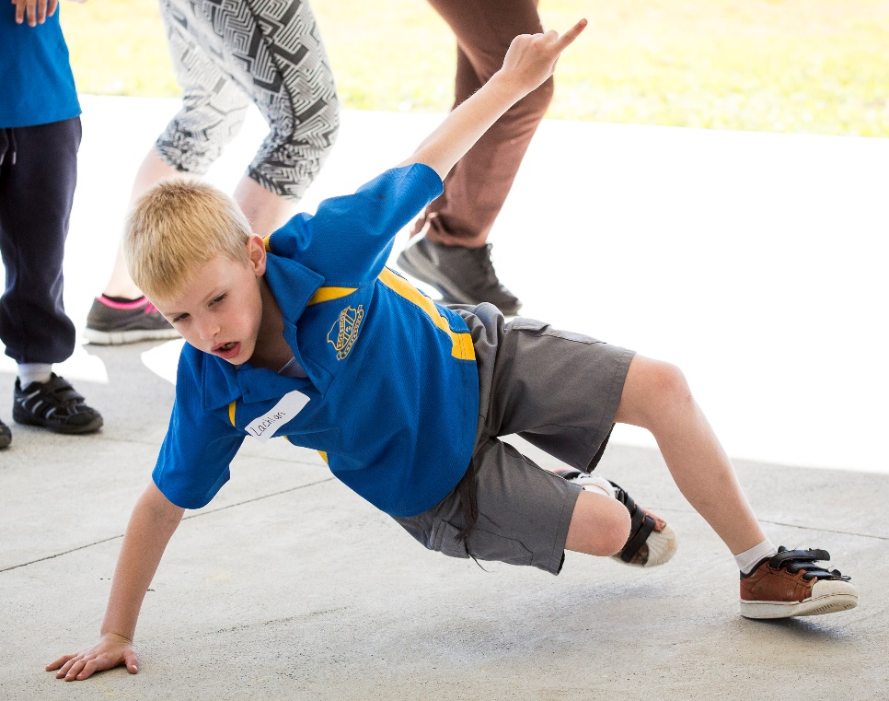
- Finalise your registration by completing and returning the Payment Advice form (final page of document). Upload the complete Payment Advice form into your online application or email directly to Arts Initiatives team: artsinitiatives@det.nsw.edu.au
Note: your place in the program is not secure until all the above steps are completed.

Key information
The student workshop is an interactive, in-person workshop.
Date | Location | Venue | Time
Monday 5 August | South Western Sydney | Strathfield North Public School | 10:00 am-2:00 pm
Tuesday 6 August | Western Sydney | The Ponds School | 10:00 am-2:00 pm
Wednesday 7 August | North Sydney | Narrabeen Lakes Public School | 10:00 am-2:00 pm
Thursday 8 August | Central Coast | Biraban Public School | 10:00 am-2:00 pm
Friday 9 August | Central Coast | Tomaree High School | 10:00 am-2:00 pm
Tuesday 13 August | Griffith | Giffith East Public School | 10:00 am-2:00 pm
Wednesday 14 August | Wagga Wagga | Wagga Wagga High School | 10:00 am-2:00 pm
Friday 16 August | Wollongong | Peterborough School | 10:00 am-2:00 pm
Who can attend?
- Students and teachers from NSW public schools.
- This workshop is suitable for students in Years 3 to 12.
- All disabilities are catered for.
- You can bring a group of students or individual students.
Program fee: $33 per student (no GST required).
Method of payment: Schools are direct debited via an Intercompany Journal (previously Sundry Tax). Organising teachers will need to return the Payment Advice page (final page of this document) by uploading it into the online application form or via email to artsInitiatives@det.nsw.edu.au. The Arts Unit will organise the direct debit after the workshop takes place.

Workshop schedule
Please note that the following schedule is a guide only, and may change based on school bell times etc. You will be notified of any changes.
Time | Activity | Duration
9:45 am | Schools arrive and sign on
10:00 am | Session 1: warm up and performance activities. | 1 hour
11:00 am | Break (recess) | 20 min
11:20 am | Session 2: movement and performance activities | 1 hour 10 min
12:30 pm | Break (lunch) | 30 min
1:00 pm | Session 3: review, final show and tell | 1 hour
2:00 pm | Workshop concludes

What to bring and wear
On the day of the workshop, students should:
- Wear their school’s sports uniform
- Bring a water bottle, packed lunch, and snacks
- Bring relevant protective wear (e.g. hat, school jacket)

Supervising teachers
On the day of the workshop, accompanying teachers are required to:
- Organise transport and accompany students to/from the workshop
- Ensure that students with medical needs have their relevant medication and Health Care or ASCIA plans. Please also ensure that due care has been exercised to accommodate student’s medical and dietary needs on the day of the workshop.
- Identify any students who suffer from allergies which may lead to anaphylactic shock and inform the coordinator at the workshop.
- As per the NSW Department of Education Excursion Policy, teachers are required to bring a first aid kit (including an Epipen) to the workshop venue.
- Supervise students during the workshop and during breaks
- Accompanying teachers are encouraged to actively participate in the workshop activities
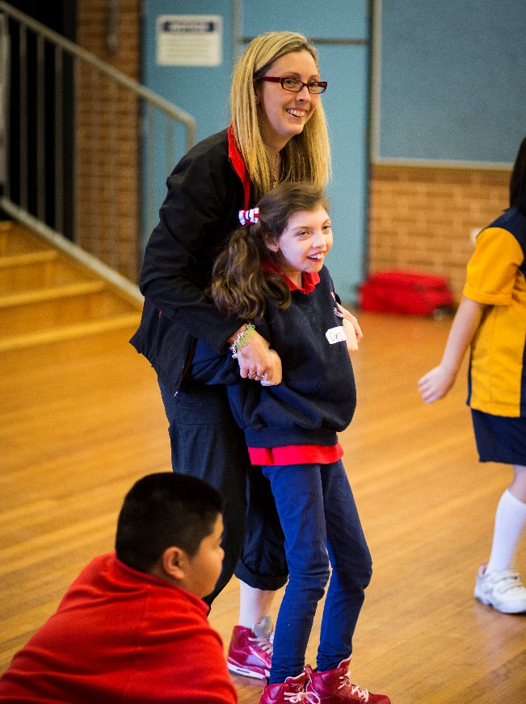
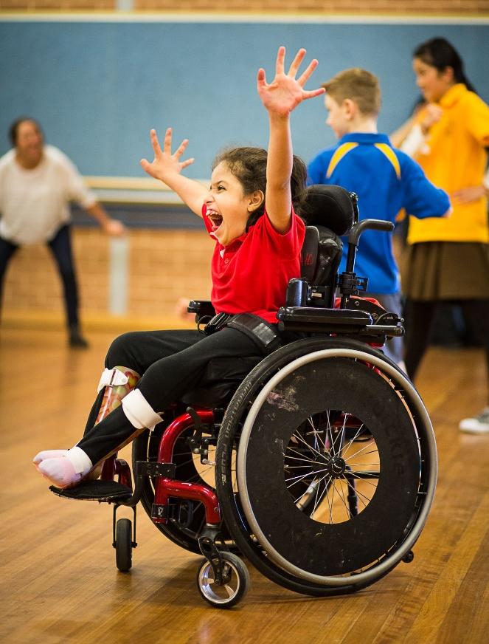
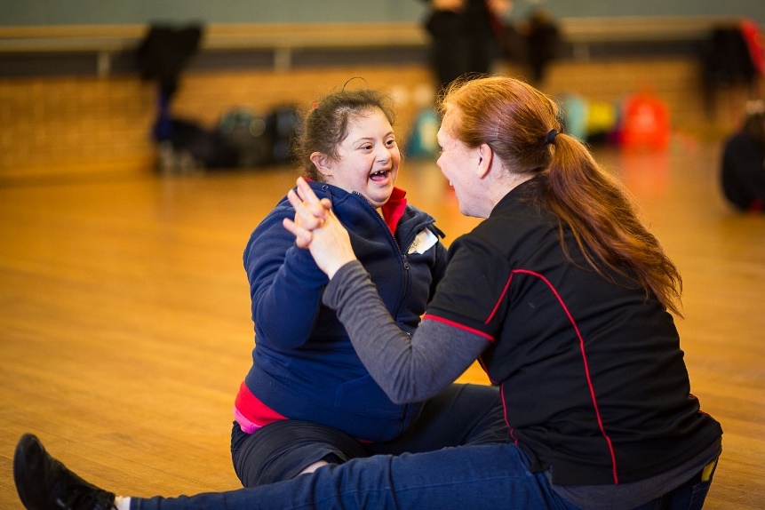

Tutor information
Virginia Ferris
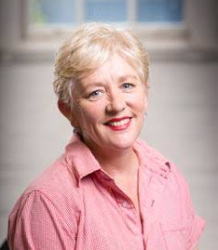
Virginia Ferris is a successful artistic director, choreographer, specialised tutor and adjudicator who has created hundreds of events and shows in Australia and internationally. She has an extensive list of teaching credits including holding the position of head of dance for The McDonald College Performing Arts School, and has been a dance tutor for Western Sydney University, NIDA, University of NSW, Sydney Dance Company and more.
She has worked as a project manager and creative consultant for over 6 years with the NSW Department of Ageing, Disability and Home Care on the NSW Seniors Week and ‘Don’t DIS my ABILITY’ campaigns and their associated events.
Virginia has been the choreographer of the D’Arts Ensemble (students with disability) in the Schools Spectacular since 2012. The D’Arts Ensemble has become a regular highlight of the show. She has also completed an Auslan (Australian Sign Language) Certificate Course to be able to communicate better with people who are hearing-impaired or deaf.

Christine Gillett
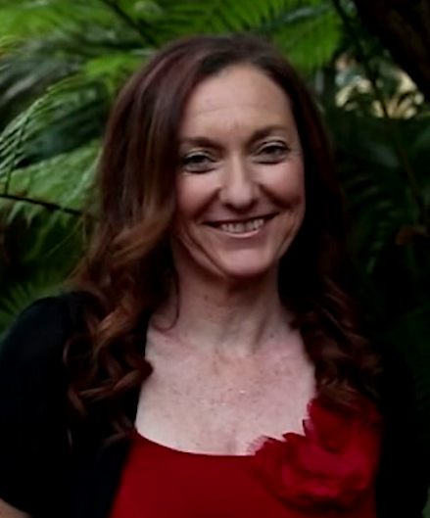
Chris Gillett is a choreographer, dance facilitator and adjudicator with a career spanning 30 years in the entertainment industry. Christine is trained in RAD ballet, American jazz, tap, Irish dance, Zumba, aerobics and yoga.
Chris has been the dance facilitator at Hornsby Heights PS for 15 years. She is also the dance and movement specialist for children of Chinese, Vietnamese and Korean backgrounds with disability as part of the Special Children’s Services Centre. Chris has devised programs for seniors, carers and children with disability at Anglicare Cabramatta.
Chris has been part of the D’Arts program for a number of years, developing resources and running school workshops for students with disability. She currently teaches for CaSPA at Eileen O Connor, a specialised school for students with disability.

